|  |  |
| --- | --- |
| WeTeachTrades Corp.  Technology Working Together | Abstract  WeTeachTrades.com Corporation offers courses and career opportunities for anyone looking to skip four years of college education. This paper will highlight on how IT can help the business gain a competitive advantage. How will IT participate in a decisive role in the company’s strategy on the whole?  Sneha P  CS782 Assignment2 |

**Table of Contents**

Introduction 1

IT Provides Competitive and Operational Advantage 1

Software as a Service (SaaS) 3

Big Data 5

Mobile Communication 6

Communication and Collaboration Systems 7

Social Media Communication 8

Augmented Reality 9

Other Technologies 10

Conclusion 12

References 12

**Table of Figures**

Figure 2 - 1 Emerging Technologies 1

Figure 2 - 2 Software as a Service (SaaS) 3

Figure 2 - 3 On-premises application vs. SaaS application 4

Figure 2 - 4 SaaS providers 4

Figure 2 - 5 Why Big Data? 5

Figure 2 - 6 Mobile technology 6

Figure 2 - 7 Collaboration Requires Communication 7

Figure 2 - 8 Social media: A powerful marketing tool 8

Figure 2 - 9 Facebook as a source of political news 9

Figure 2 - 10 Augmented Reality in Culinary 9

Figure 2 - 11 What is IaaS? 10

Figure 2 - 12 Development and IT Operations 11

Figure 2 - 13 Monolithic architecture vs. Microservice architecture 12

Introduction

*WeTeachTrades.com* offers training programs in several trades, and the courses are full-time, encompassing numerous subjects that takes at least 6 months for completion. The courses are tailored to help students find jobs as a hairstylist, electrician, plumber, culinary, auto body, etc. *WeTeachTrades.com* industry incorporates tuition finance counseling, advertising, distance education, placements, internships, andhands-on training sites.

This paper discusses how *WeTeachTrades.com* can use emerging technologies to outperform its competitors and restructure its operations in a way that it is hard for its competitors to understand or duplicate. The introduction of cloud computing services, big data, microservices, augmented reality, mobile communication, social media communication, DevOps, and communication and collaboration systems can help levitate a business’s competitive advantage. Out of these, which emerging technologies are a good fit for *WeTeachTrades.com*? The sections hereafter will examine which one of these emerging technologies *WeTeachTrades.com* can employ and the reasons behind the selection of these technologies.

IT Provides Competitive and Operational Advantage

Enterprise leaders understand they ought to plan for technological disruptions in the following years. Staying up-to-date on emerging technologies is an arduous chore but exploring them can resolve business challenges and increase the company’s earnings. IT facilitates structure that influences the processes, competency, sustainability, and value of the enterprises.

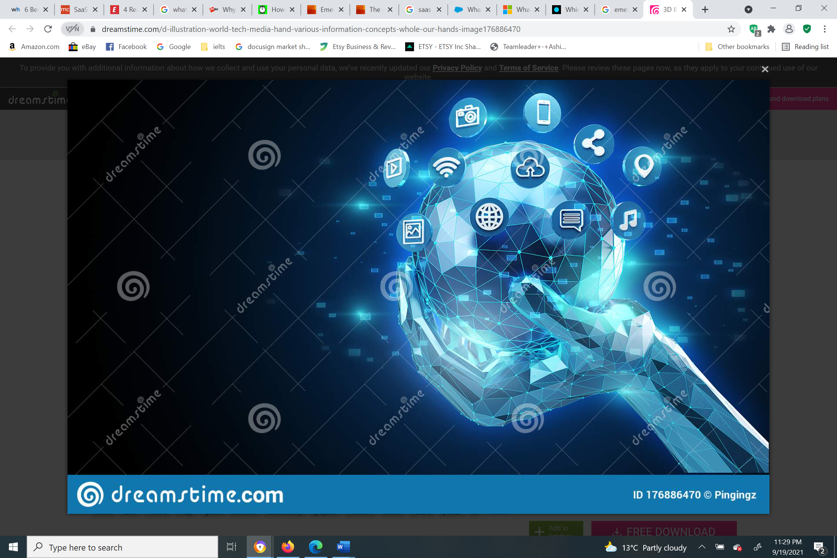

Figure 2 - 1 Emerging Technologies

Source: https://www.dreamstime.com/d-illustration-world-tech-media-hand-various-information-concepts-whole-our-hands-image176886470

The following emerging technologies can have a potential impact on *WeTeachTrades.com*’s enterprise.

1. **Software as a Service (SaaS)**

Software as a Service (SaaS) is a cloud computing service model in which applications are delivered over the Internet—as a service. (Salesforce) *WeTeachTrades.com* will require a content management system (CMS) to encourage digital marketing and communications and report digital requirements of current and prospective students and staff. *WeTeachTrades.com* shall incorporate SaaS applications such as DocuSign, Amazon Web Services (AWS), Google Workspace, etc.

1. **Big Data**

*WeTeachTrades.com* can benefit from big data as it can analyze raw data of students enrolling in the programs and turn data into a piece of meaningful information. The information can be used by the staff to understand the educational background of individual students and the manner in which students absorb academic content in real-time. The information collected will be useful for placements and internships as well.

1. **Mobile Communications**

*WeTeachTrades.com*’s faculty and students can use mobile technologies and rely on the support from these devices. Students, or consumers, can use it to collaborate with other students for a project or research. Mobile communications can also develop learning beyond classrooms as many students get the opportunity to learn courses on their handheld devices.

1. **Communication and Collaboration Systems**

*WeTeachTrades.com* shall utilize various communication and collaboration systems or services such as Zoom, Microsoft Teams, and Microsoft SharePoint to facilitate interactions outside the organization. Communication enables the exchange of information and collaboration boosts the overall efficiency and quality of the work. This technology is essential in all areas of *WeTeachTrades.com*’s business.

1. **Social Media Communication**

Social media is a set of virtual platforms that enable communicating and cooperating with a group of people by networking with each other. Apart from emails, *WeTeachTrades.com* shall use Facebook and LinkedIn to provide updates on placements, internships, and other things that both the company’s employees and customers may be interested in.

1. **Augmented Reality (AR)**

Along with hands-on training programs, *WeTeachTrades.com* shall employ augmented reality to make learning more engaging. AR shall allow *WeTeachTrades.com* to develop course materials with virtual examples containing gaming elements that will specifically help in distance education.

Software as a Service (SaaS)

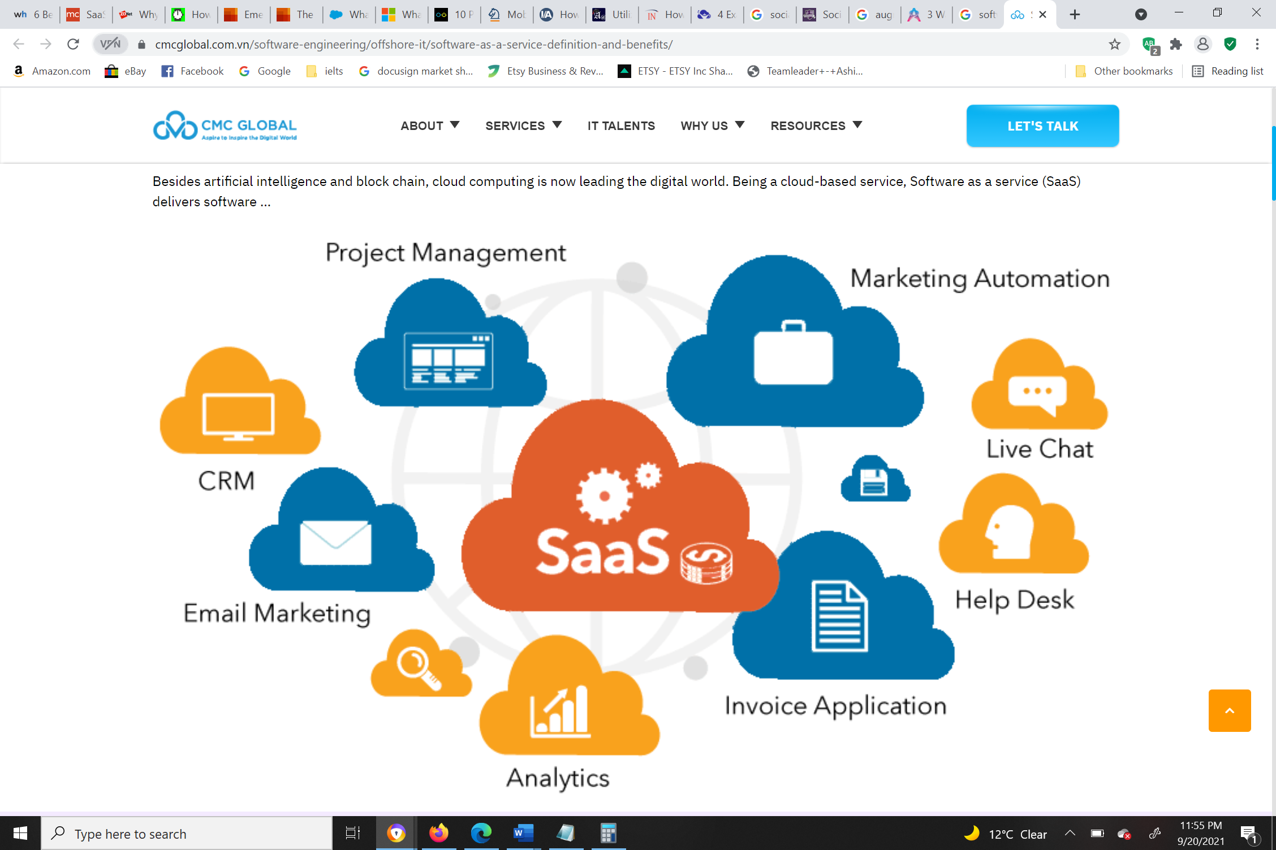

Figure 2 - 2 Software as a Service (SaaS)

*Source: https://www.cmcglobal.com.vn/software-engineering/offshore-it/software-as-a-service-definition-and-benefits/*

*WeTeachTrades.com* shall purchase a license for SaaS software and gain access to it over the Internet through cloud technology. SaaS provides a secure connection and takes rigorous actions to store data safely in the cloud; the data stored can be retrieved at any time, from any location. Since SaaS is a “pay as you go” service, there are no up-front costs for purchasing or installing software.

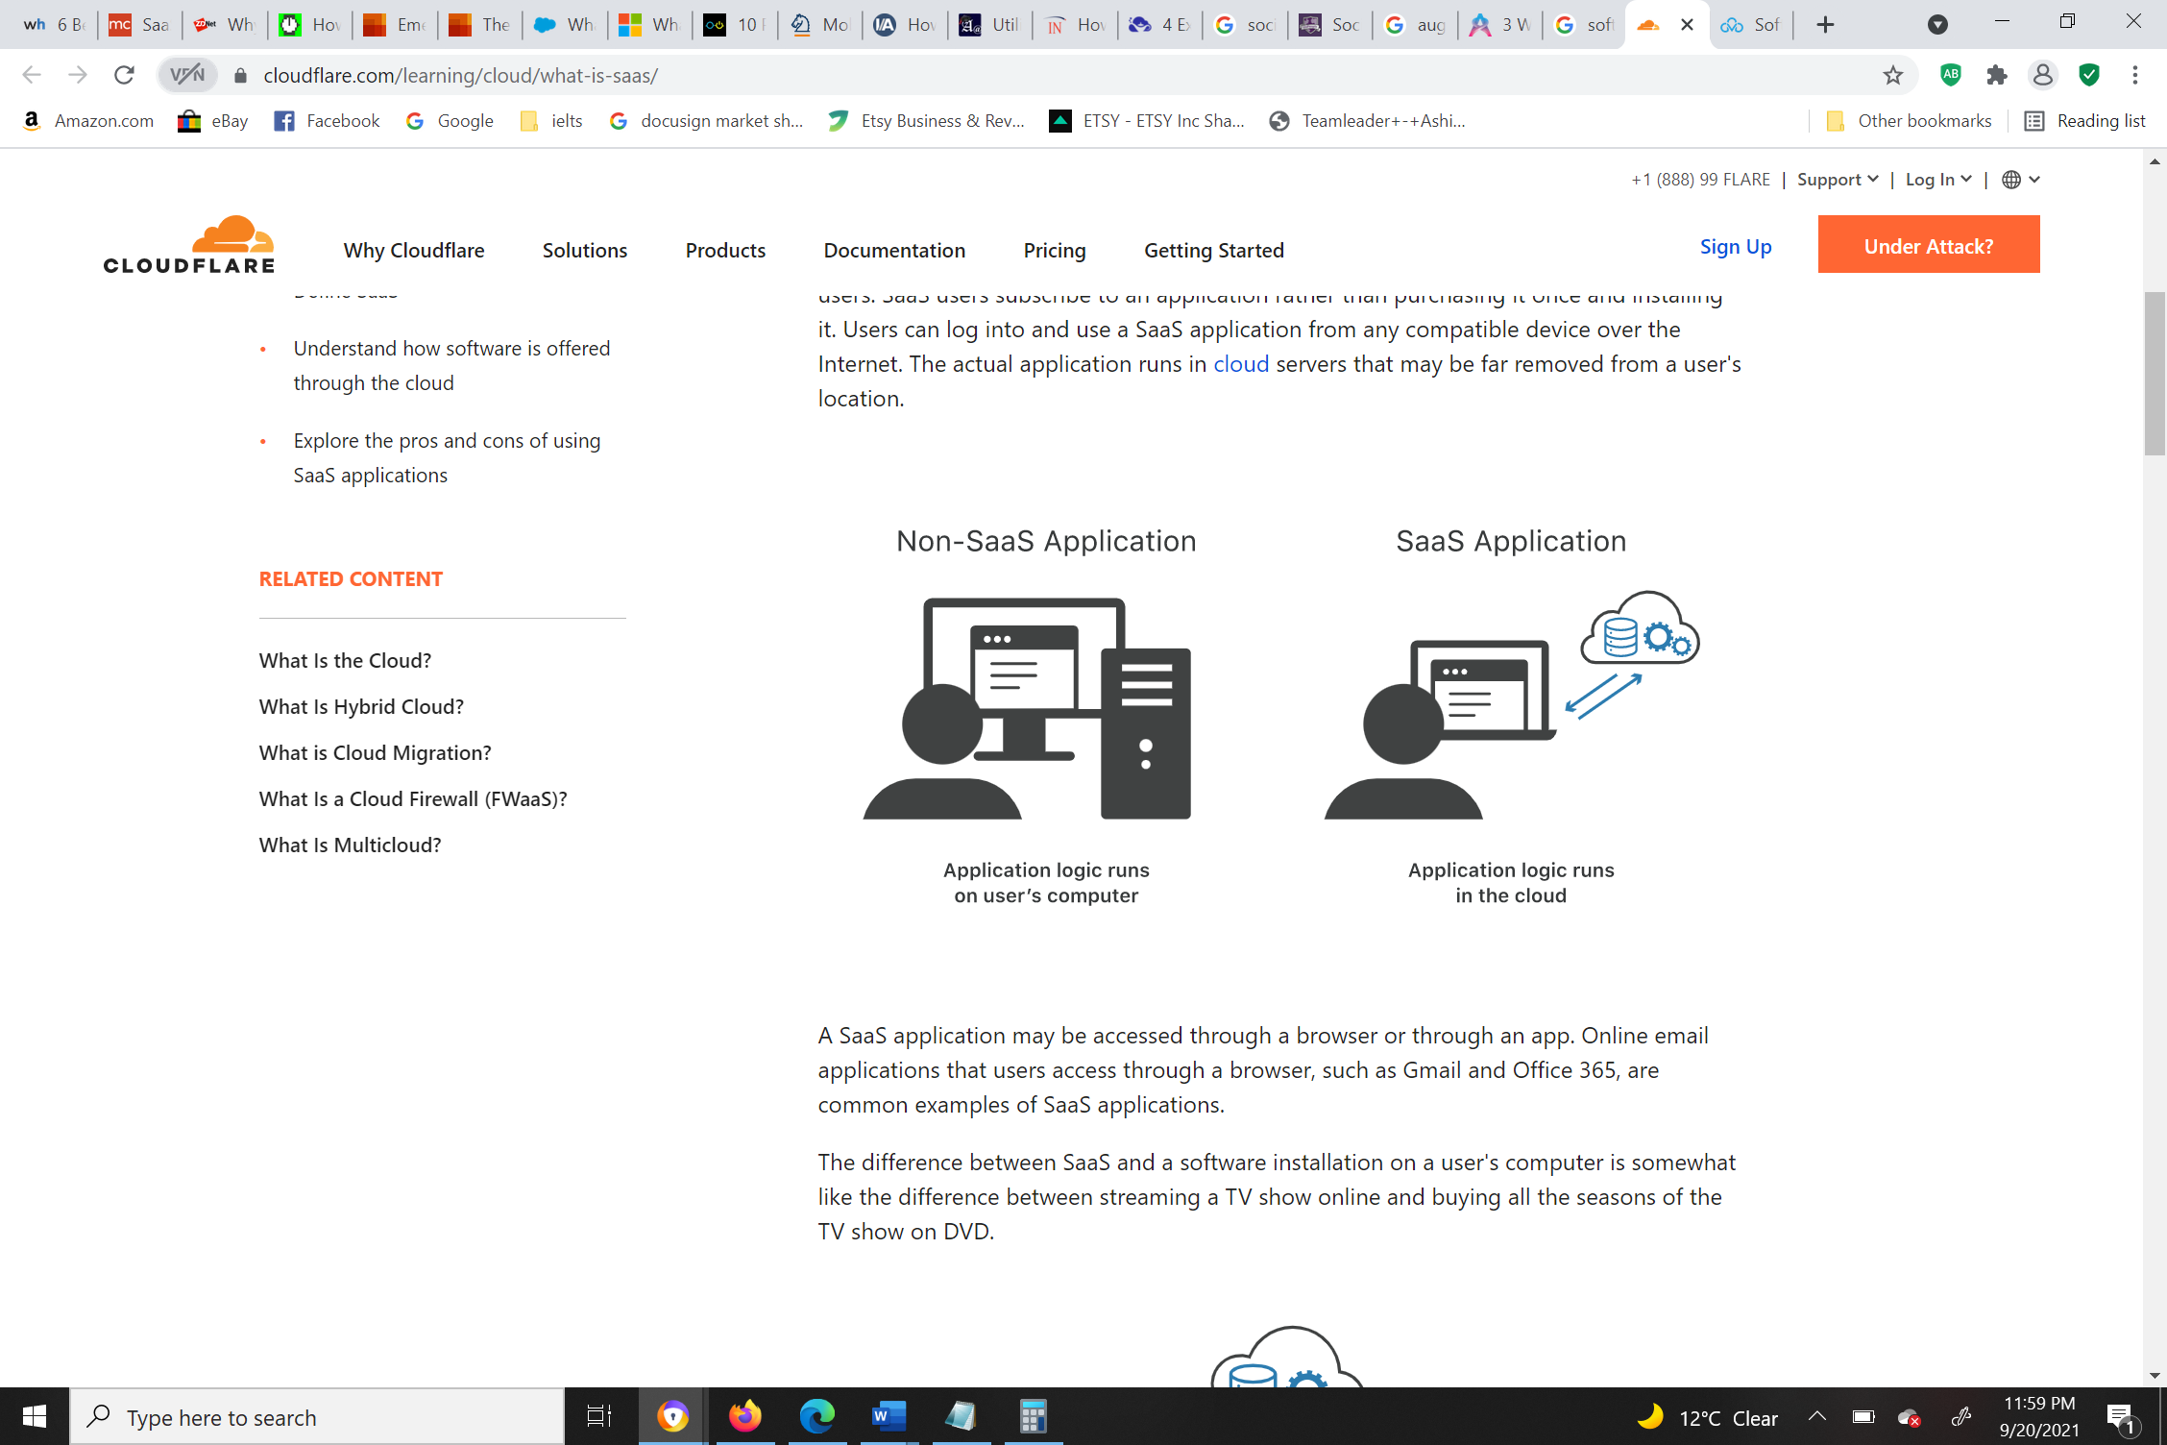

Figure 2 - 3 On-premises application vs. SaaS application

*Source: https://www.cloudflare.com/learning/cloud/what-is-saas/*

The problem with on-premises software is that when the developers who developed the software program quit the company, maintenance and repairs are in jeopardy. With SaaS, *WeTeachTrades.com* need not worry about this as the cloud provider will be responsible for expenses needed for replacements, maintenance, or security. The company need not worry about IT complexity or budget as SaaS will help prevent from splurging money excessively on assets that the company may not need. The cloud provider assembles supplies for server space, which reduces the probability of downtime. SaaS is capable of scaling up instantly to meet demand during peak time especially during admission or registration deadlines for courses offered by *WeTeachTrades.com*.

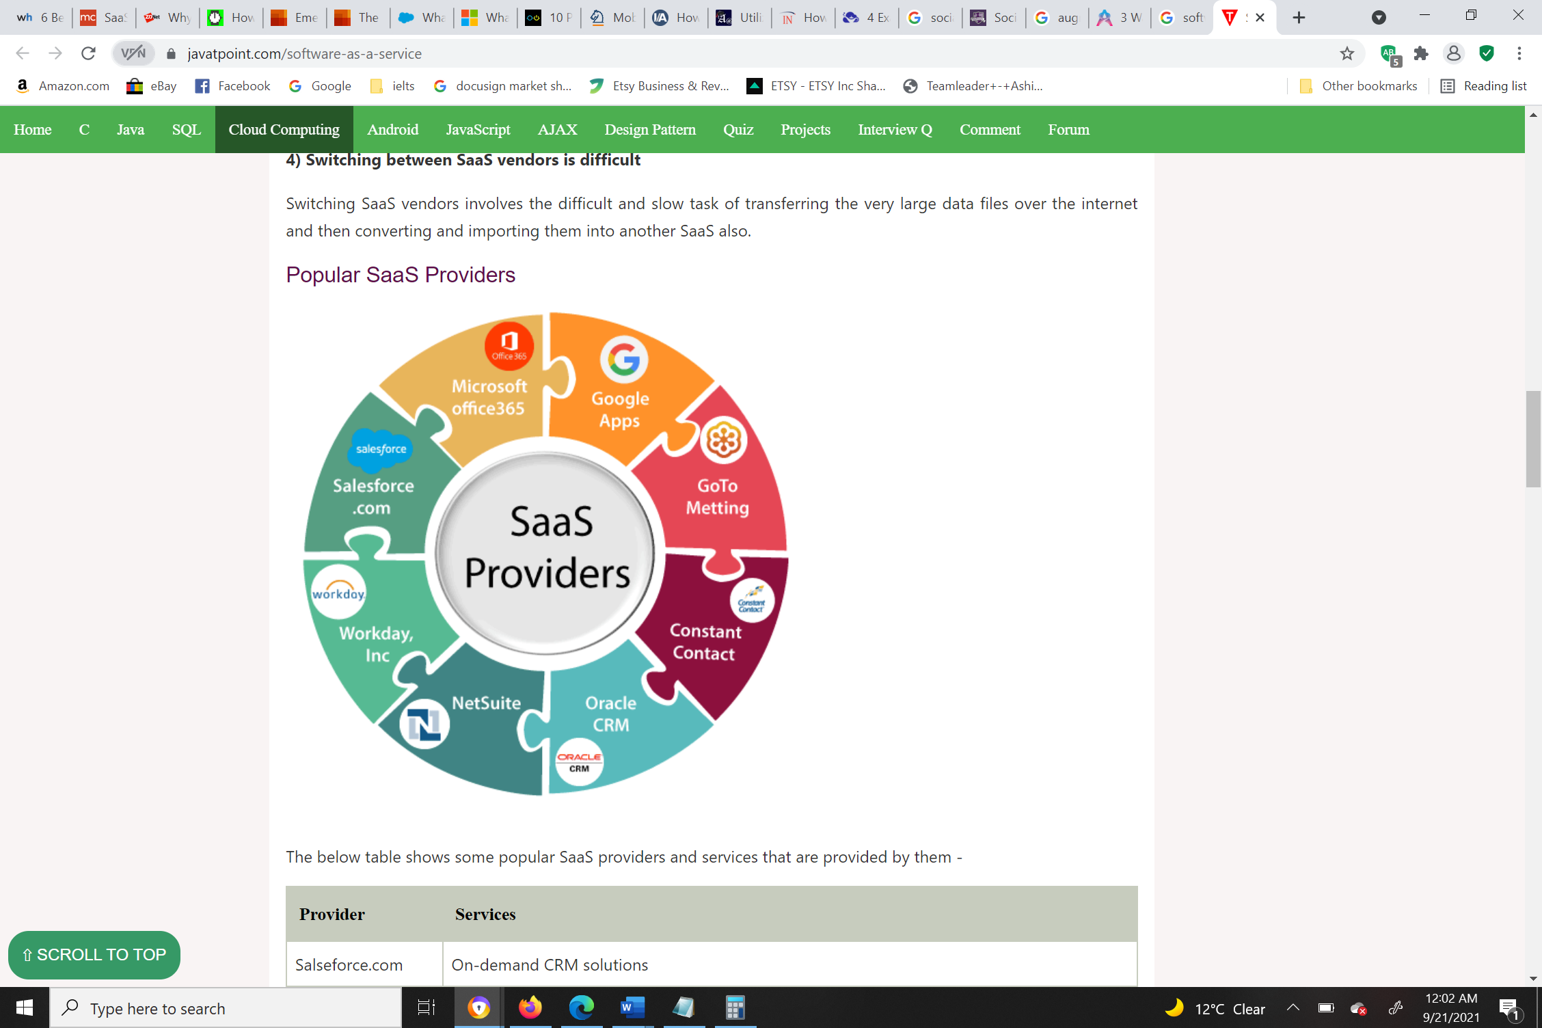

Figure 2 - 4 SaaS providers

*Source: https://www.javatpoint.com/software-as-a-service*

There are many SaaS applications: Microsoft Office 365, Salesforce, Dropbox, DocuSign, and many more. Office 365 will help employees in every business at *WeTeachTrades.com*. The finance counseling team can use MS Excel to perform calculations related to budgeting and debts for finance and store the file in OneDrive. MS Access can be the company’s database for storing data about its employees and clients. The data can be used for analysis and reporting. Outlook can be used for email interactions. DocuSign enables e-signatures globally, lowering manual tasks; customers can retrieve and sign documents from anywhere in the world, at any time. The organization shall opt to rent efficient and enterprise business systems such as enterprise resource planning (ERP), supply chain management (SCM), and customer relationship management (CRM) systems.

However, there will be some challenges while engaging with SaaS applications. First, the company will have to rely on the vendor’s resources as the whole thing is controlled by the vendor. Second, ensuring the security of confidential data stored in the cloud.

Big Data

The description of big data is data that encompasses more variety, entering in growing volumes and with extra velocity. This is also called the three Vs. (Oracle)

In simple terms, big data is bigger, additional intricate data sets, notably from the latest data sources. These data sets are so huge that conventional software that processed data cannot handle them. However, these huge volumes of data can be utilized to deal with challenges in business that may have been hard to tackle in the past. (Oracle)

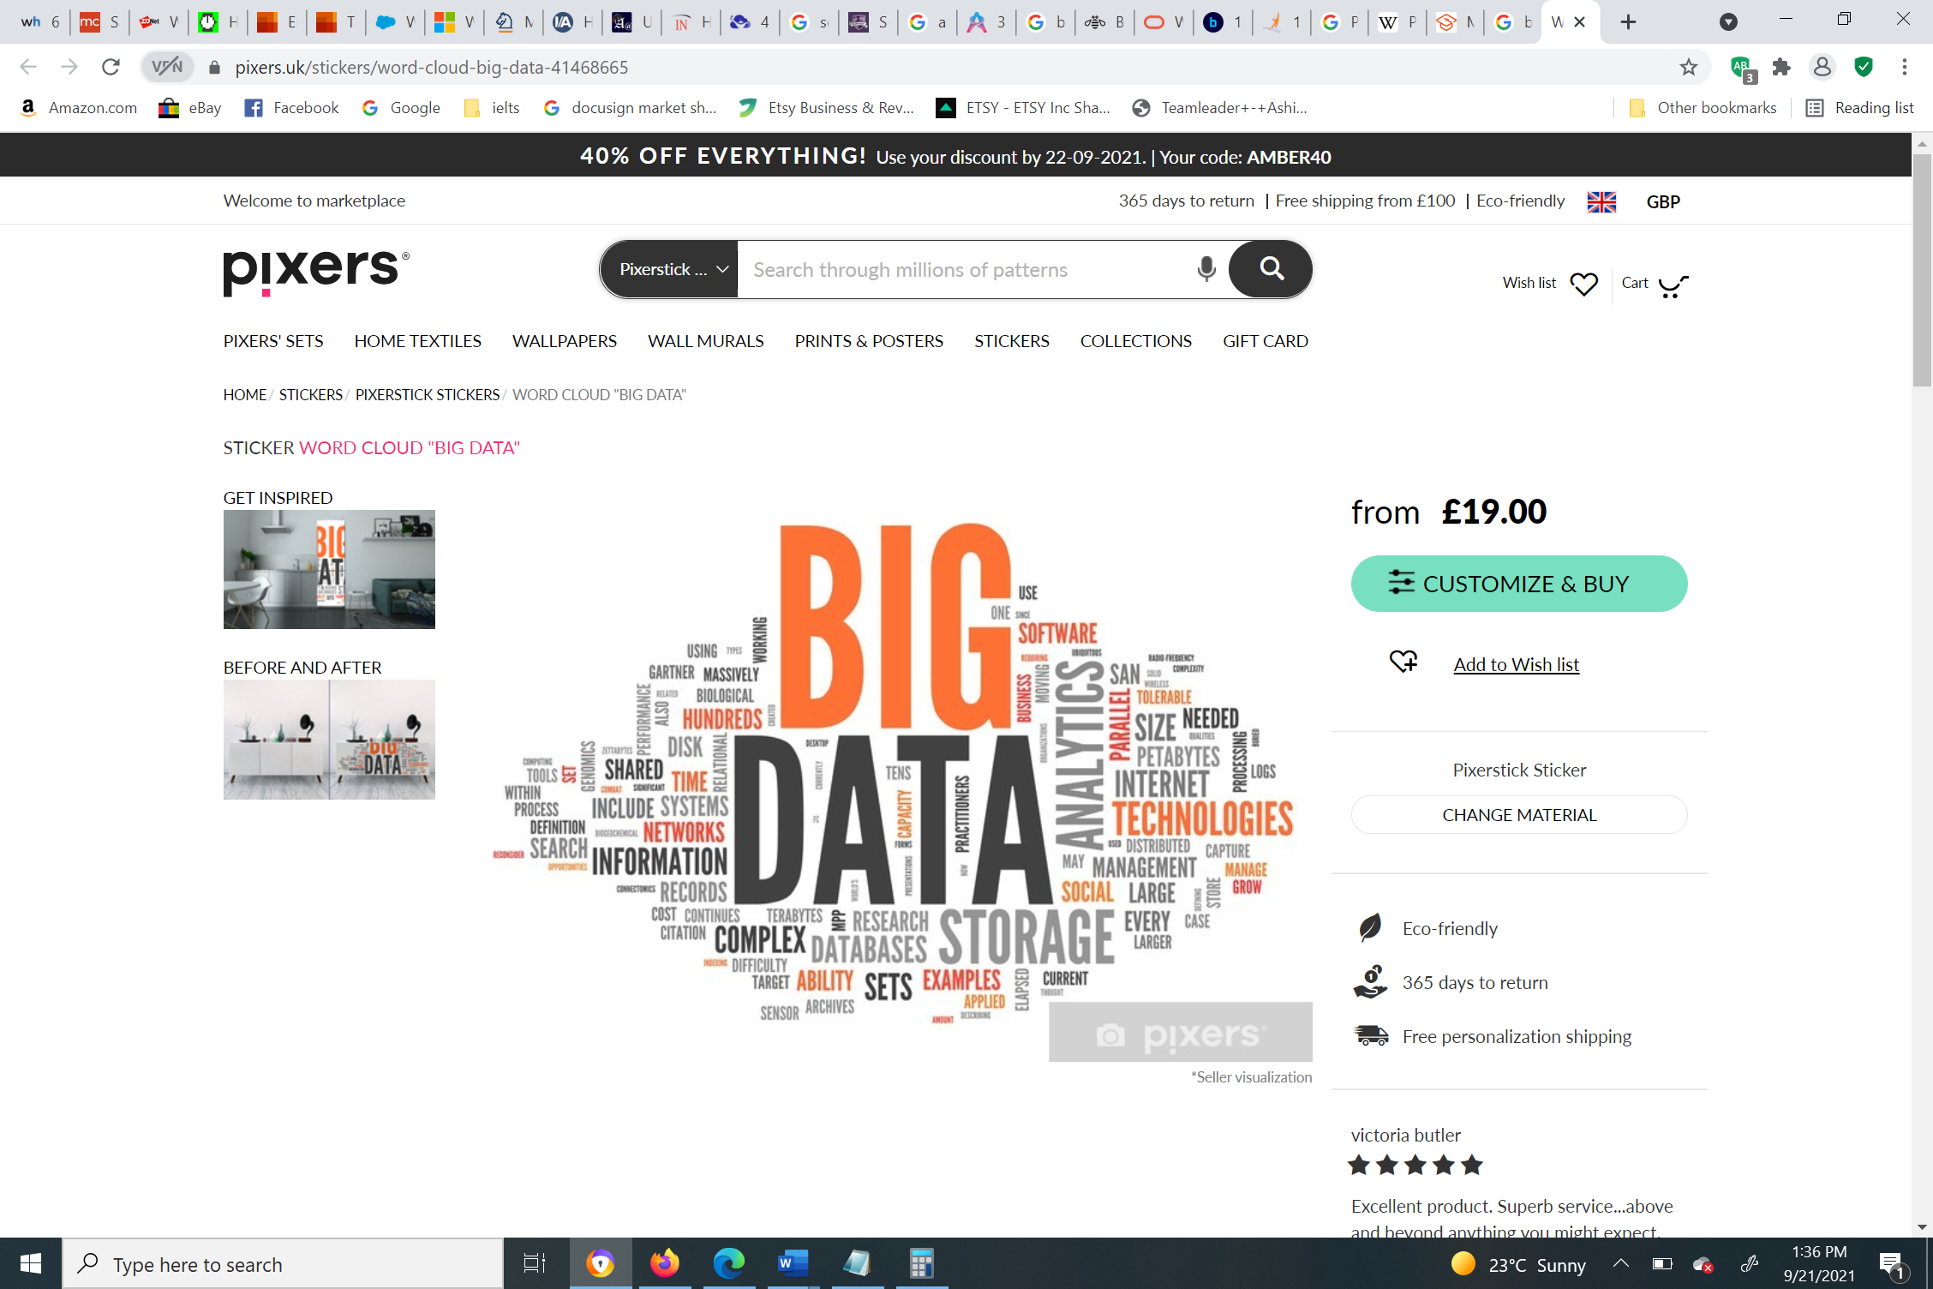

Figure 2 - 5 Why Big Data?

*Source: https://pixers.uk/stickers/word-cloud-big-data-41468665*

The advertising team at *WeTeachTrades.com* can utilize big data to enable personalized marketing by which customized content can be delivered to recipients through the collection and analysis of data. *WeTeachTrades.com* shall use big data to track the performance of employees (staff/ faculty for work hours) and customers (students for their grades and courses enrolled).

Georgia State University (GSU) started using big data and analytics in 2011 to stop students from dropping out of their degree and support them in achieving their undergraduate degree. The analytics would include analysis data on students’ grades and attendance. Moreover, analytics would alert the department whenever a student is underperforming. This helps student advisers reach out to the students before they make costlier mistakes. The university has seen its 4-year graduation rates increase by 7% ever since they incorporated big data. (GSU)

Mobile Communication

The purpose of mobile communication is to let users connect with others in any location, devoid of physical media like cables or wires. *WeTeachTrades.com* will assist its employees with legitimate corporate demands for mobile communication devices by distributing these devices. The customers also benefit from using mobile communication devices. Wireless standards like 4th generation (4G) and 5th generation (5G) mobile networks will be deployed. In the case of students, they shall be able to access course materials and emails on their phones or tablets. The organization will use a combination of Transmission Control Protocol (TCP) and User Datagram Protocol (UDP) for exchange of information.



Figure 2 - 6 Mobile technology

*Source: https://www.istockphoto.com/photo/business-person-working-at-office-desk-wearing-smart-watch-gm522866144-91824451*

*WeTeachTrades.com* will consider a bring your own device (BYOD) policy for students and employees so they are able to use their personal laptops, cell phones, and tablets. This should save some expenses from the organization’s end. However, there is a risk involved with personal devices. If a personal device is lost, the organization’s data stored on the device is exposed. Furthermore, more expertise in IT would be required as individual devices will be different. To avoid security issues, access to sensitive data shall not be made on personal devices.

Communication and Collaboration Systems

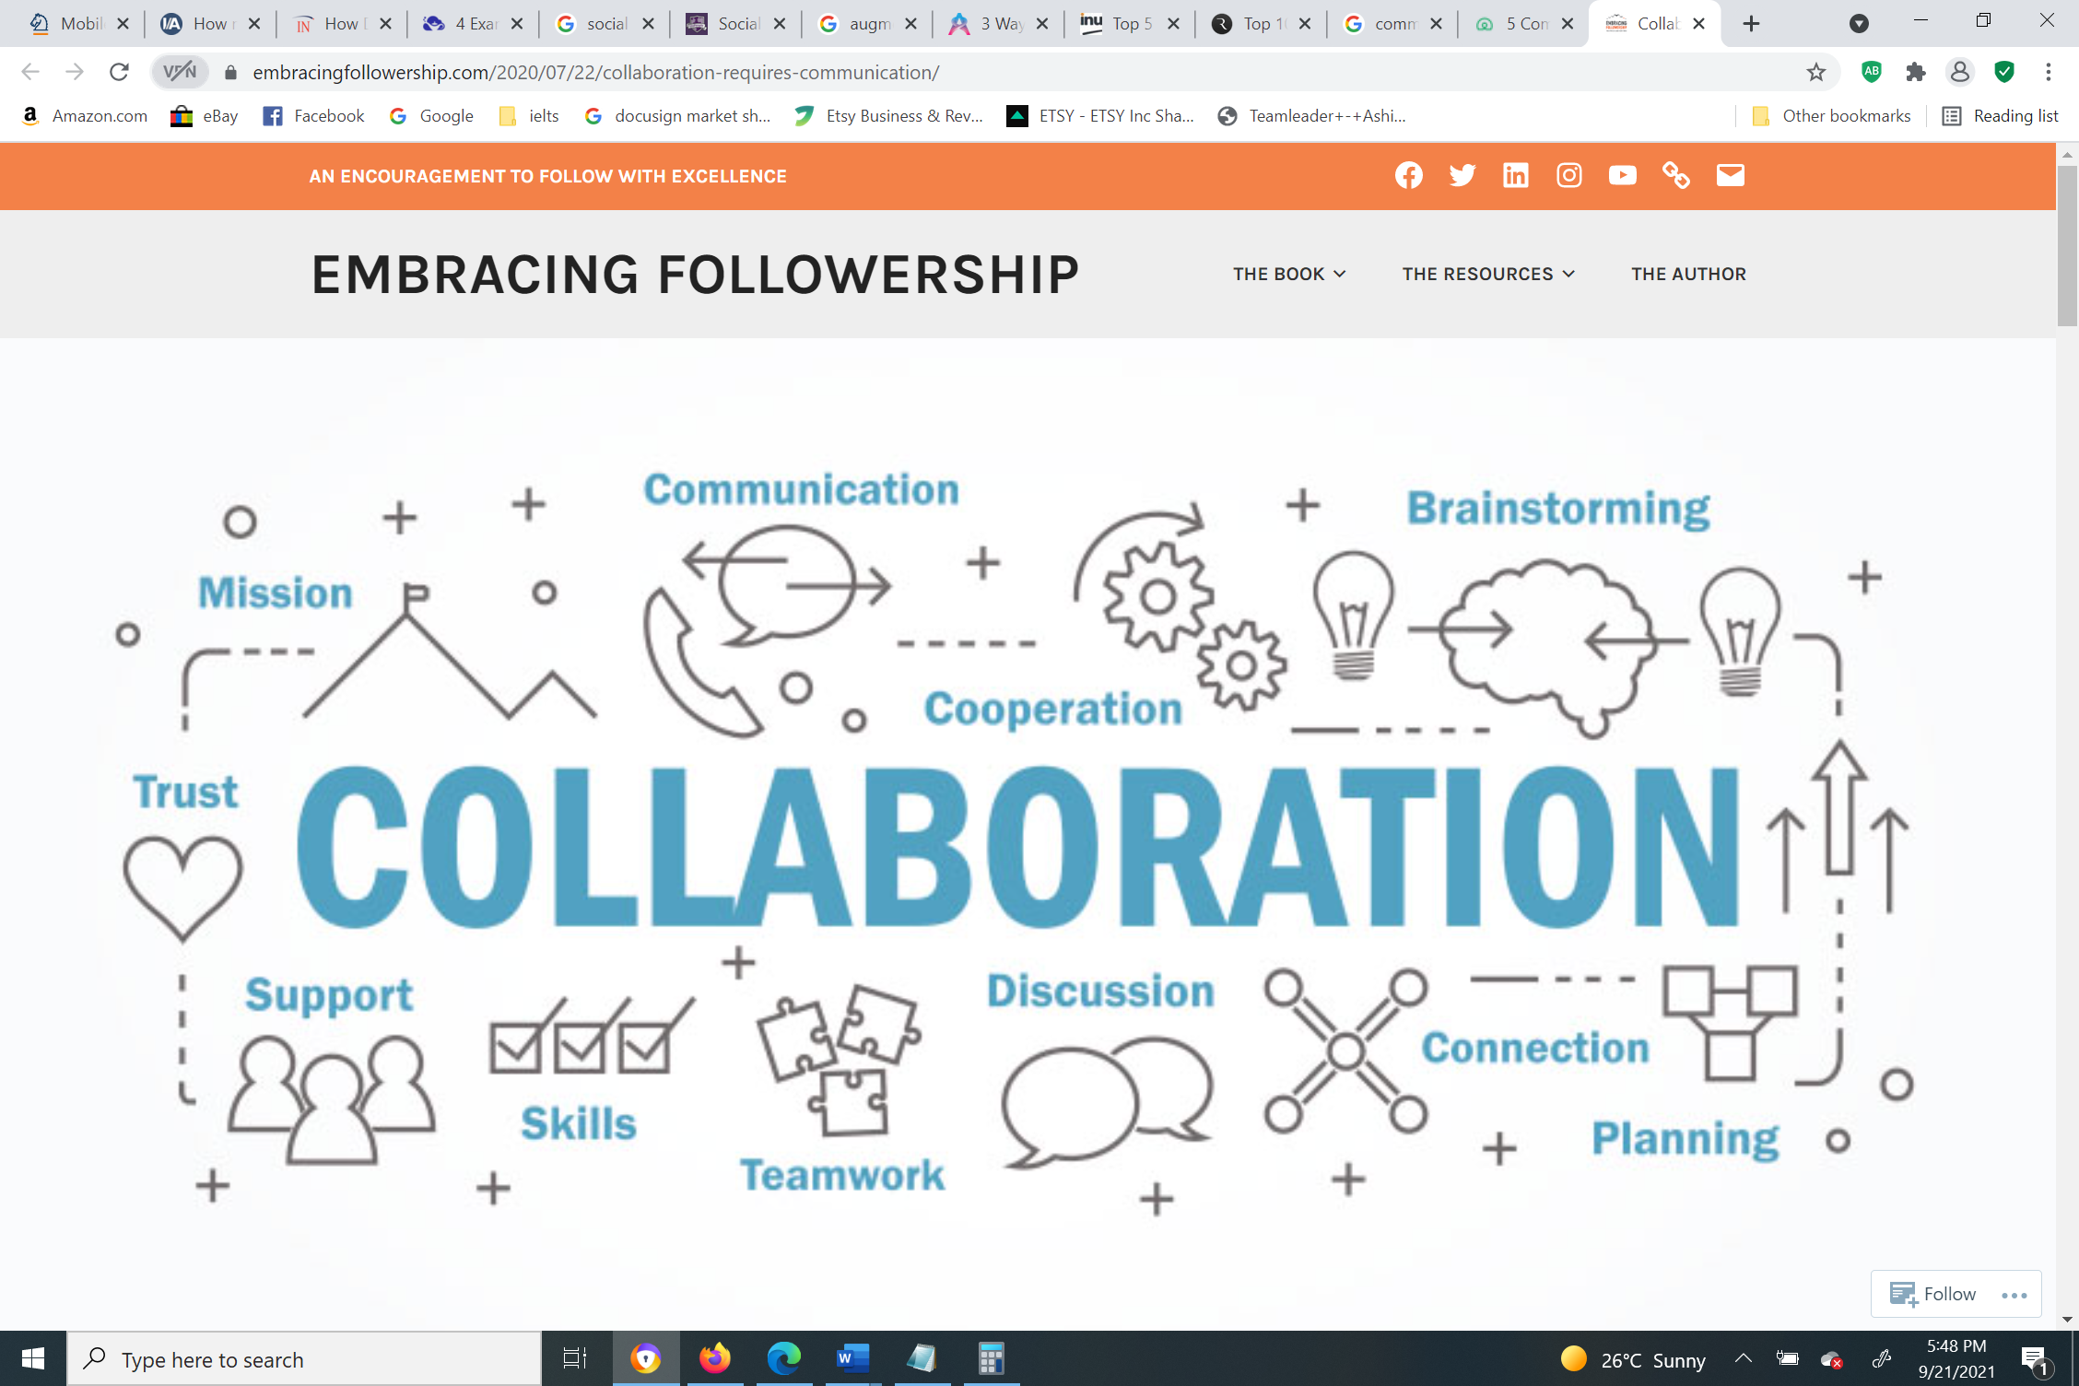

Figure 2 - 7 Collaboration Requires Communication

*Source: https://embracingfollowership.com/2020/07/22/collaboration-requires-communication/*

To make communication and exchange of information more effective, *WeTeachTrades.com* shall offer communication and collaboration services and tools such as discussion forums, emails, wikis, and blogs. Audio and video streaming service such as Adobe Media Server will be used to advertise content to viewers all over the world. This is particularly helpful for streaming orientation and training programs, and also for remote learning. The organization will invest in instant messaging (IM) which typically involves a chatbot that automatically responds to users’ queries. Instant messaging not only advances communication but also saves communication overheads and improves customer support. The organization shall incorporate applications such as WhatsApp and Skype for business purposes. Applications like Zoom and Microsoft Teams can be used for virtual classrooms, meetings, and conference purposes. Collaborative work systems enforce structures and policies to regulate ethics, conducts, and procedures that foster teamwork between various individuals in the organization to accomplish administrative objectives. Examples of collaborative work systems include Xerox DocuShare and Microsoft SharePoint.

Social Media Communication

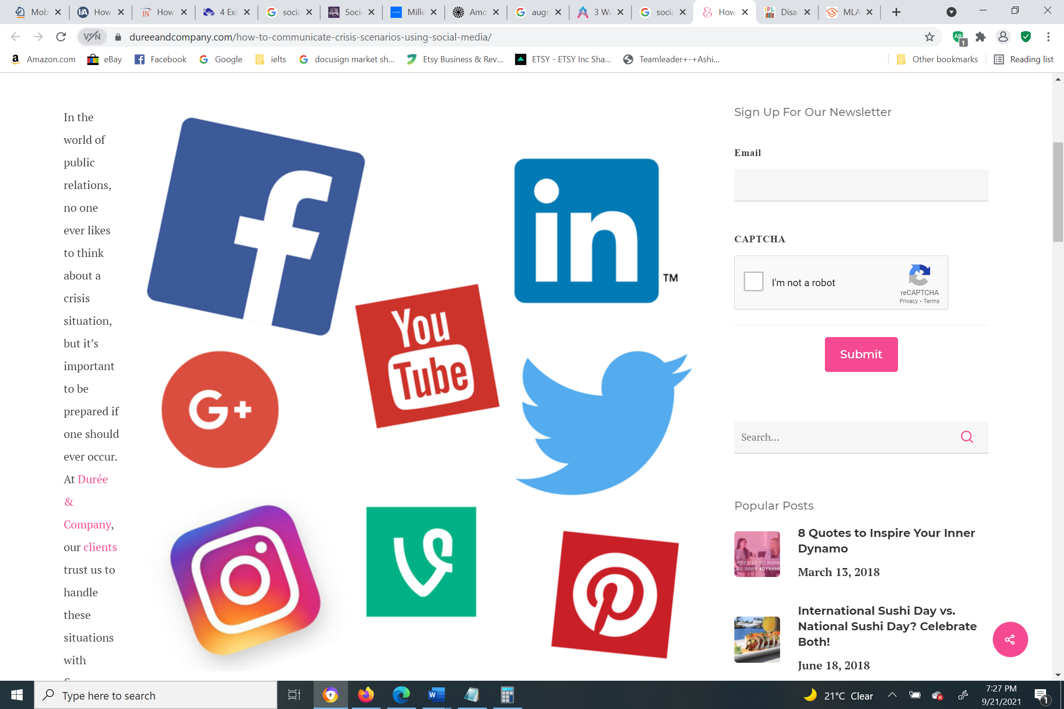

Figure 2 - 8 Social media: A powerful marketing tool

*Source: https://dureeandcompany.com/how-to-communicate-crisis-scenarios-using-social-media/*

Social media provides channels of connections between individuals where they build, communicate, and exchange knowledge or information in a simulated environment. The marketing team at *WeTeachTrades.com* shall handle the organization's primary accounts on social networking sites such as LinkedIn, Twitter, YouTube, Facebook, and Instagram.

*WeTeachTrades.com* shall use social media to reach out to its current and potential candidates for distance education and draw employers for placements and internships. LinkedIn serves as a great medium to connect to professional candidates and employers. People are likely to “share” or “like” what they read on social media. When they share a post, the number of people reading the post increases and information spreads faster than TV ads or word of mouth. This is also a downside of social media as misinformation and disinformation can spread fast and harm the organization’s reputation. Hence, posting on social media requires a lot of deliberation and relevance.

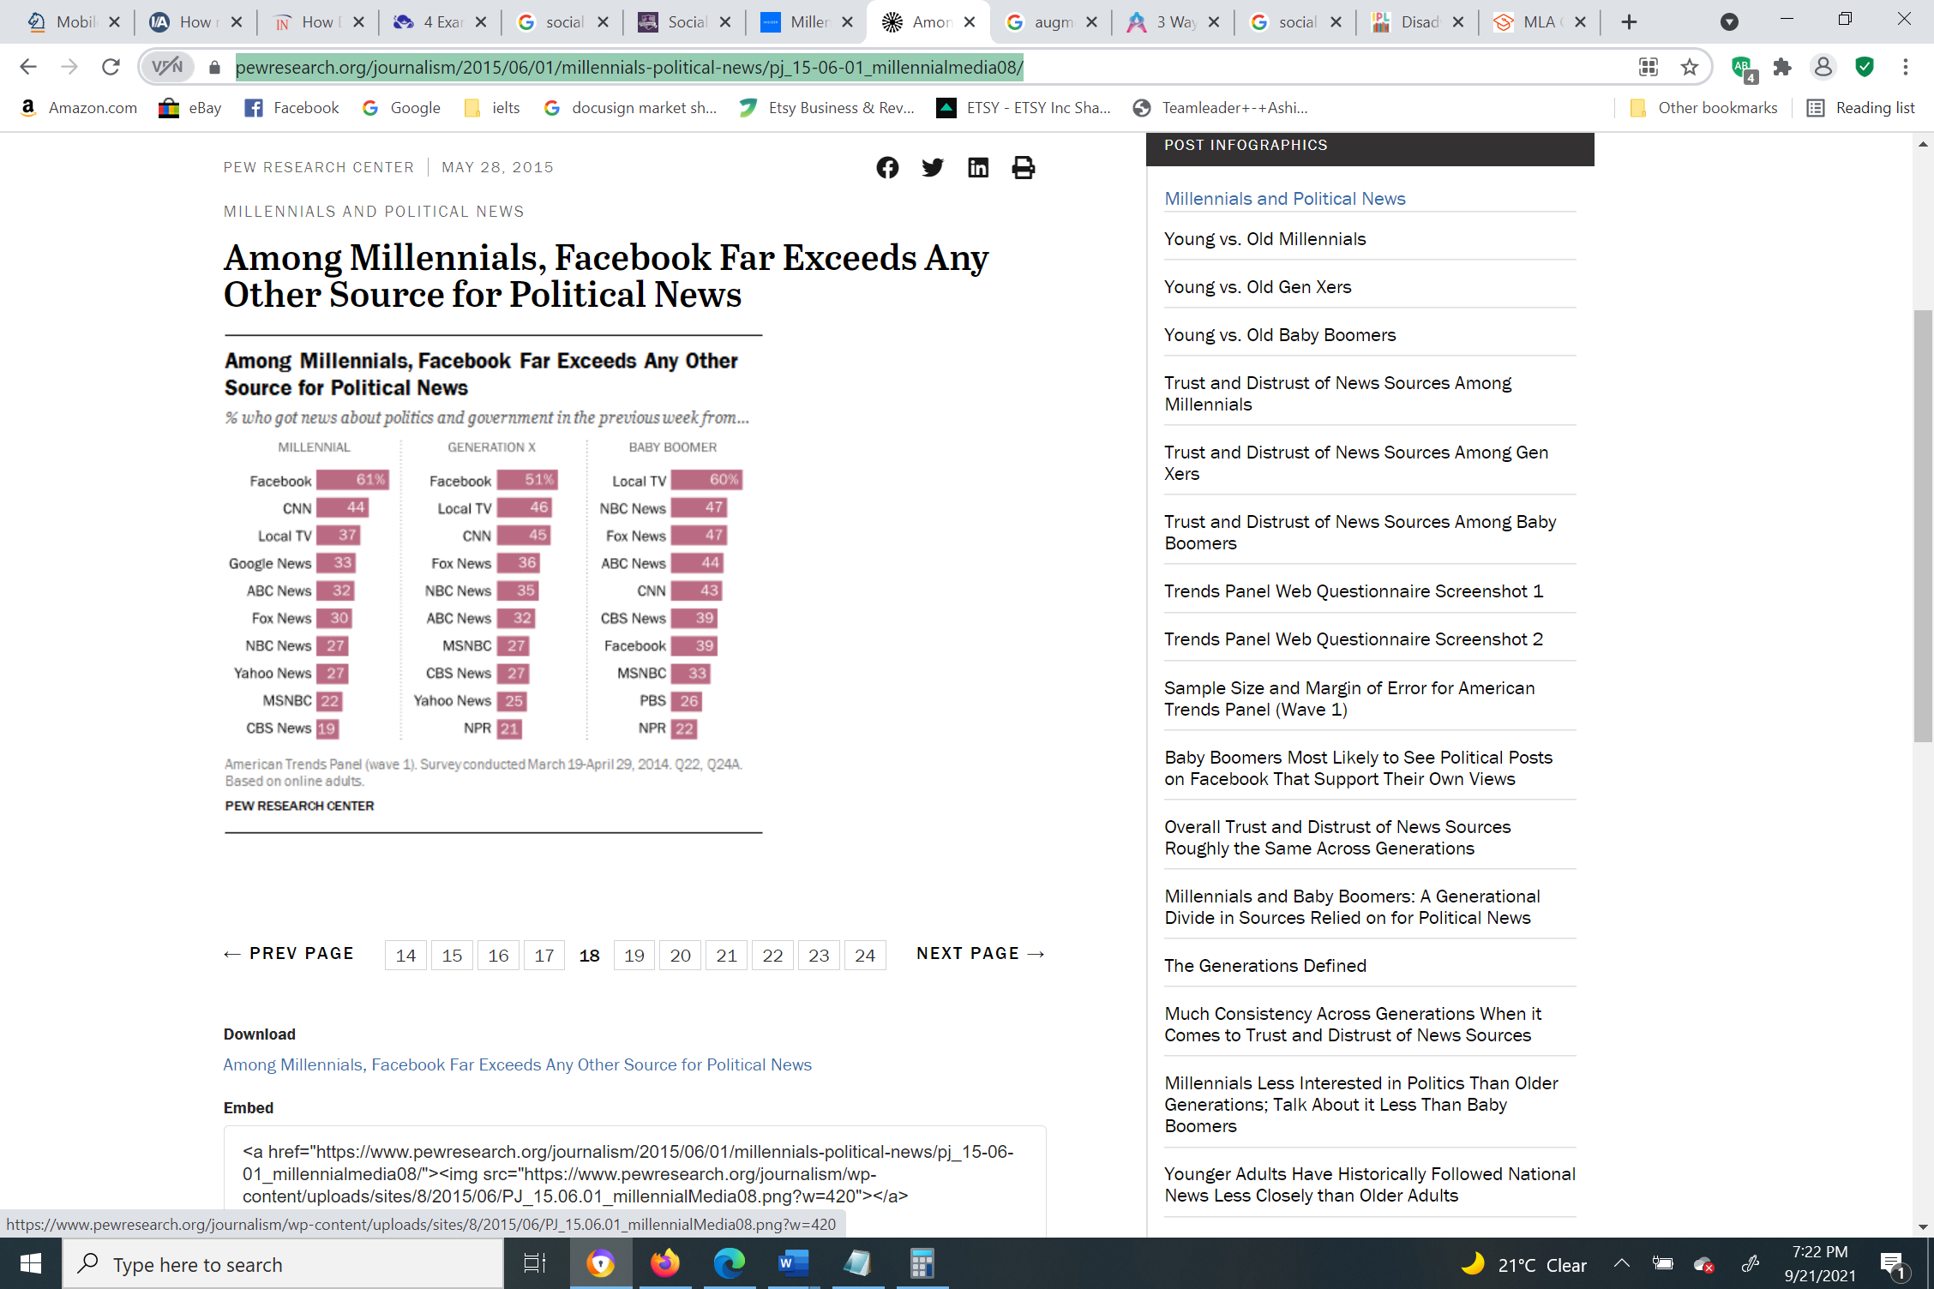

Figure 2 - 9 Facebook as a source of political news

*Source: https://www.pewresearch.org/journalism/2015/06/01/millennials-political-news/pj_15-06-01_millennialmedia08/*

According to a study by Pew Research Center, 61% of millennials reported reading political news on Facebook. (Pew Research Center, 2015)

Augmented Reality

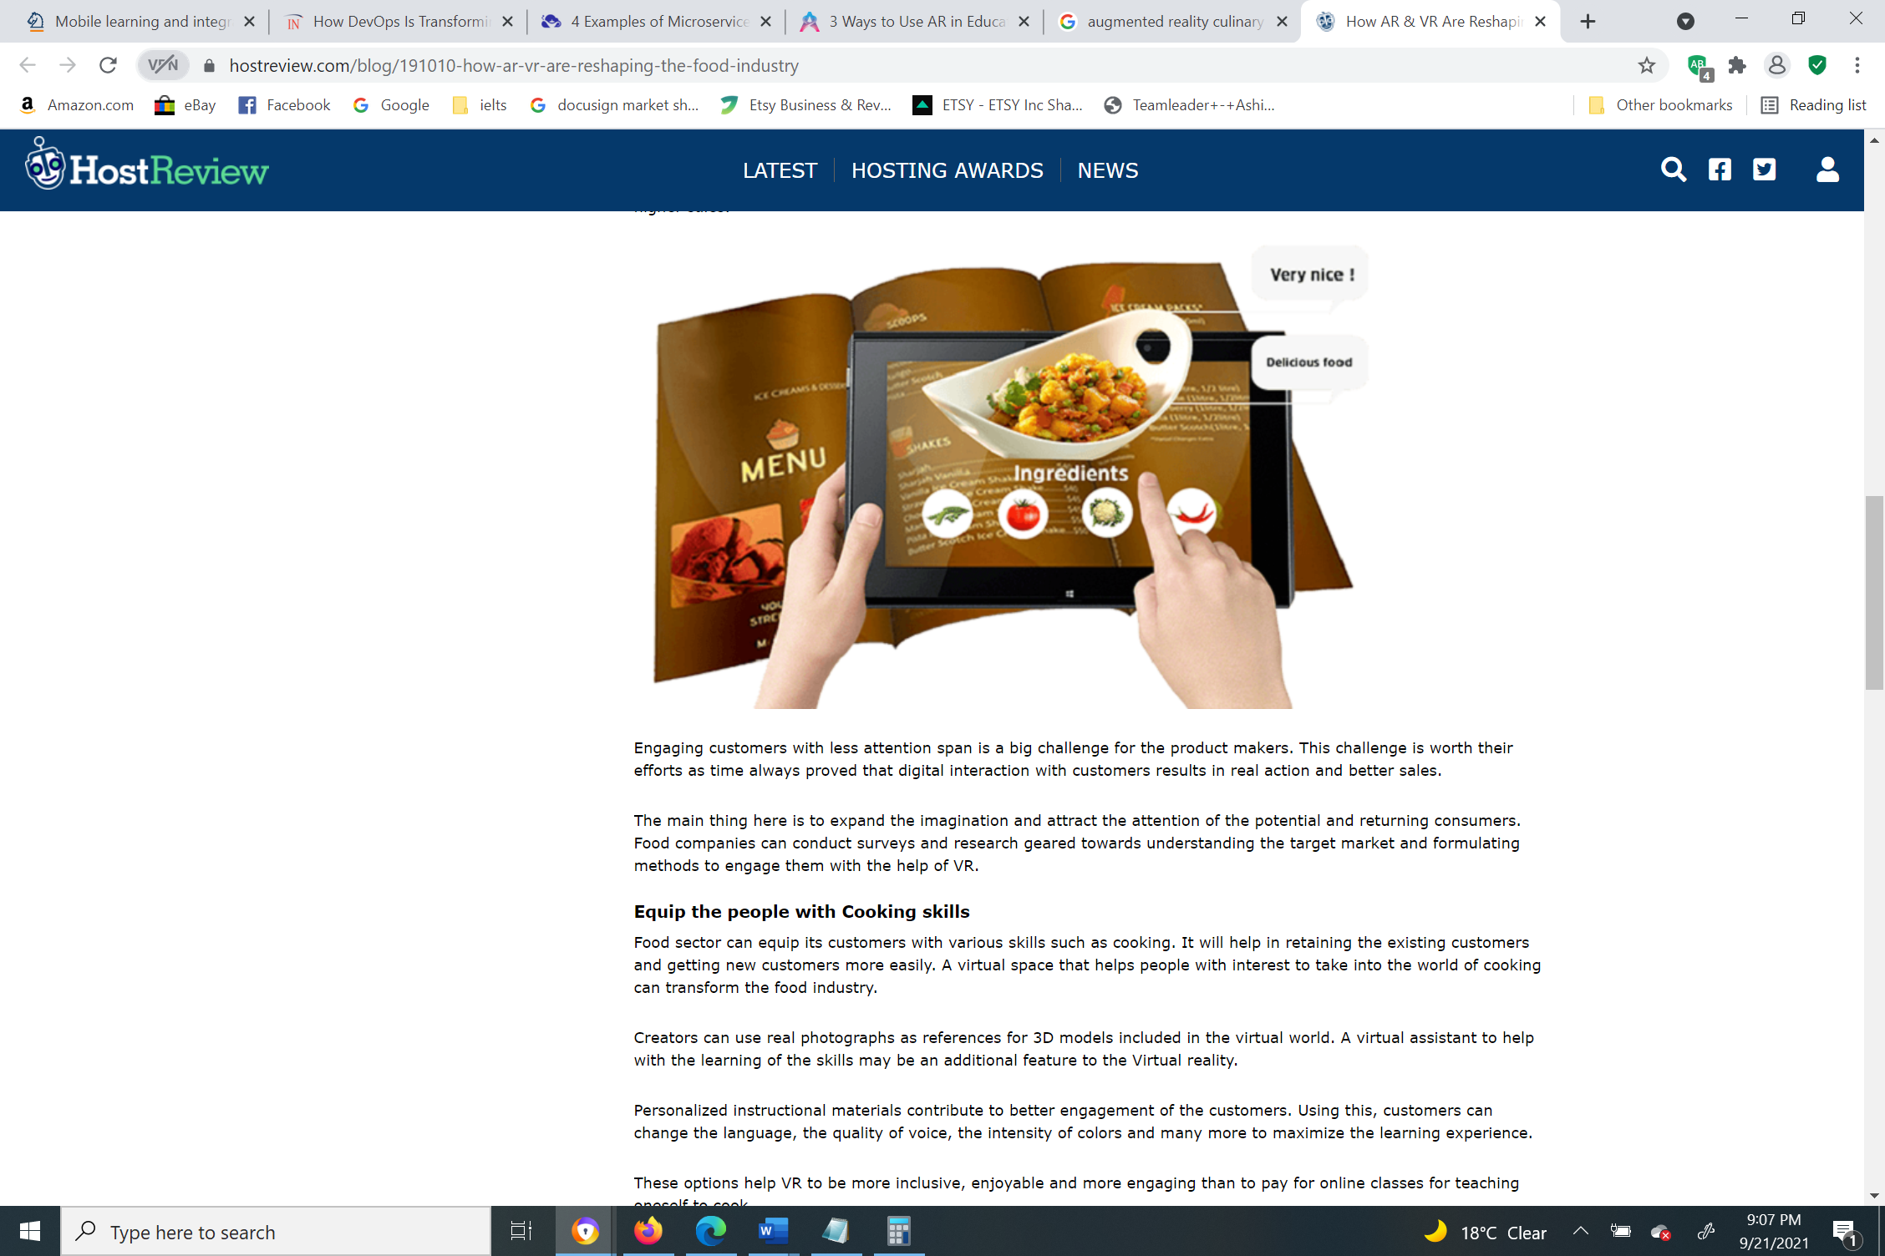

Figure 2 - 10 Augmented Reality in Culinary

*Source: https://www.hostreview.com/blog/191010-how-ar-vr-are-reshaping-the-food-industry*

Augmented reality (AR) transfers digital content and information onto the real world in such a way that they are present with you, in your own space. (Google) Ikea’s mobile app and Nintendo’s Pokémon Go are some of the popular applications that utilize AR.

*WeTeachTrades.com* shall integrate AR into its course/ study materials for students. The virtual examples in the courses shall be integrated with AR to leverage the learning process. For instance, students enrolled in the culinary program will be provided with AR-supported culinary software that will facilitate them to learn cooking virtually. This means they will get the hands-on training they need without actually performing the activity. In this case, students do not need to spend on ingredients or use real utensils as it is a virtual cooking experience. There are limitations to these technologies; student will learn to cook but will not be able to experiment with their own recipes and evaluate the flavor of the dish.

Other Technologies

The other emerging technologies such as microservices, DevOps, and Infrastructure as a Service (IaaS) are less relevant to *WeTeachTrades.com* compared to the technologies chosen in the above sections. These technologies are of lesser importance right now, but *WeTeachTrades.com* may employ them later when the need arises.

* **Infrastructure as a Service (IaaS)**

Infrastructure as a Service (IaaS) is also called hardware as a service as only the hardware supplied by the cloud provider and everything else is bought by the organization. Some of the common examples of IaaS include Microsoft Azure, Amazon Web Services (AWS), and IBM Cloud.

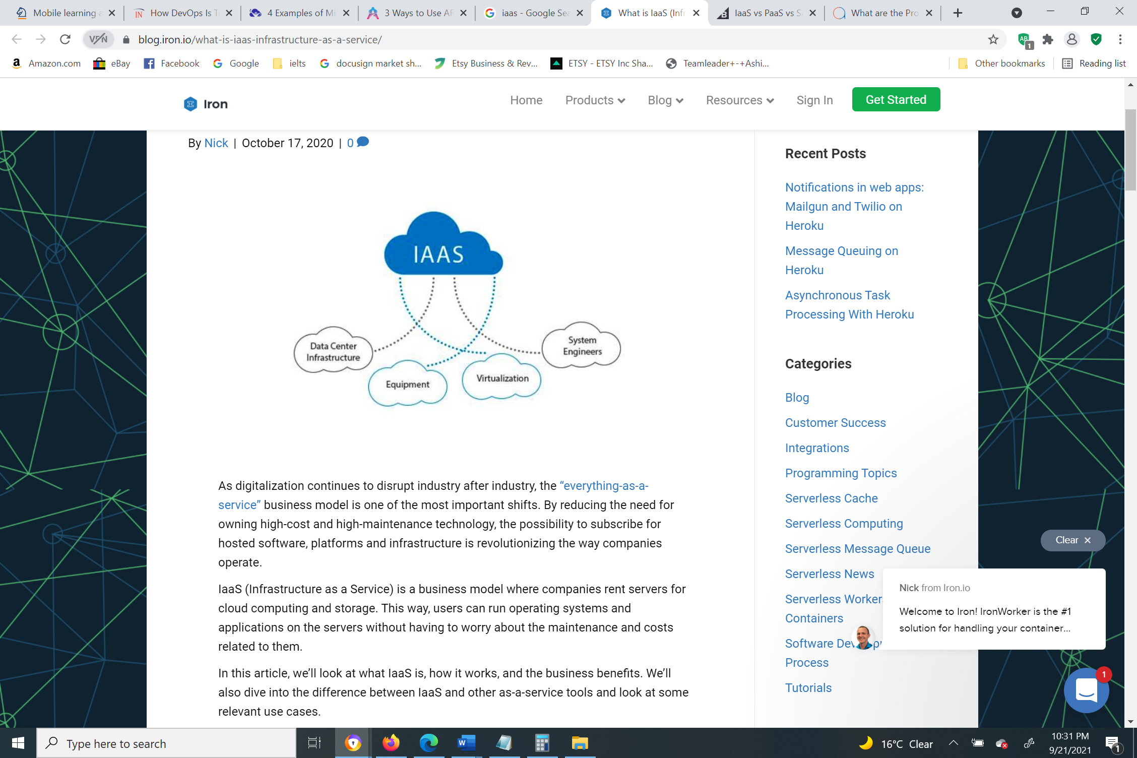

Figure 2 - 11 What is IaaS?

*Source: https://blog.iron.io/what-is-iaas-infrastructure-as-a-service/*

With IaaS, as opposed to SaaS, *WeTeachTrades.com* must be accountable for controlling facets such as runtime, operating systems, applications, data, and middleware. The organization will have to invest time and money in recruiting and training staff required for maintenance. Devoid of sufficient training and supplies, supervising and running the resources will be challenging.

* **DevOps**

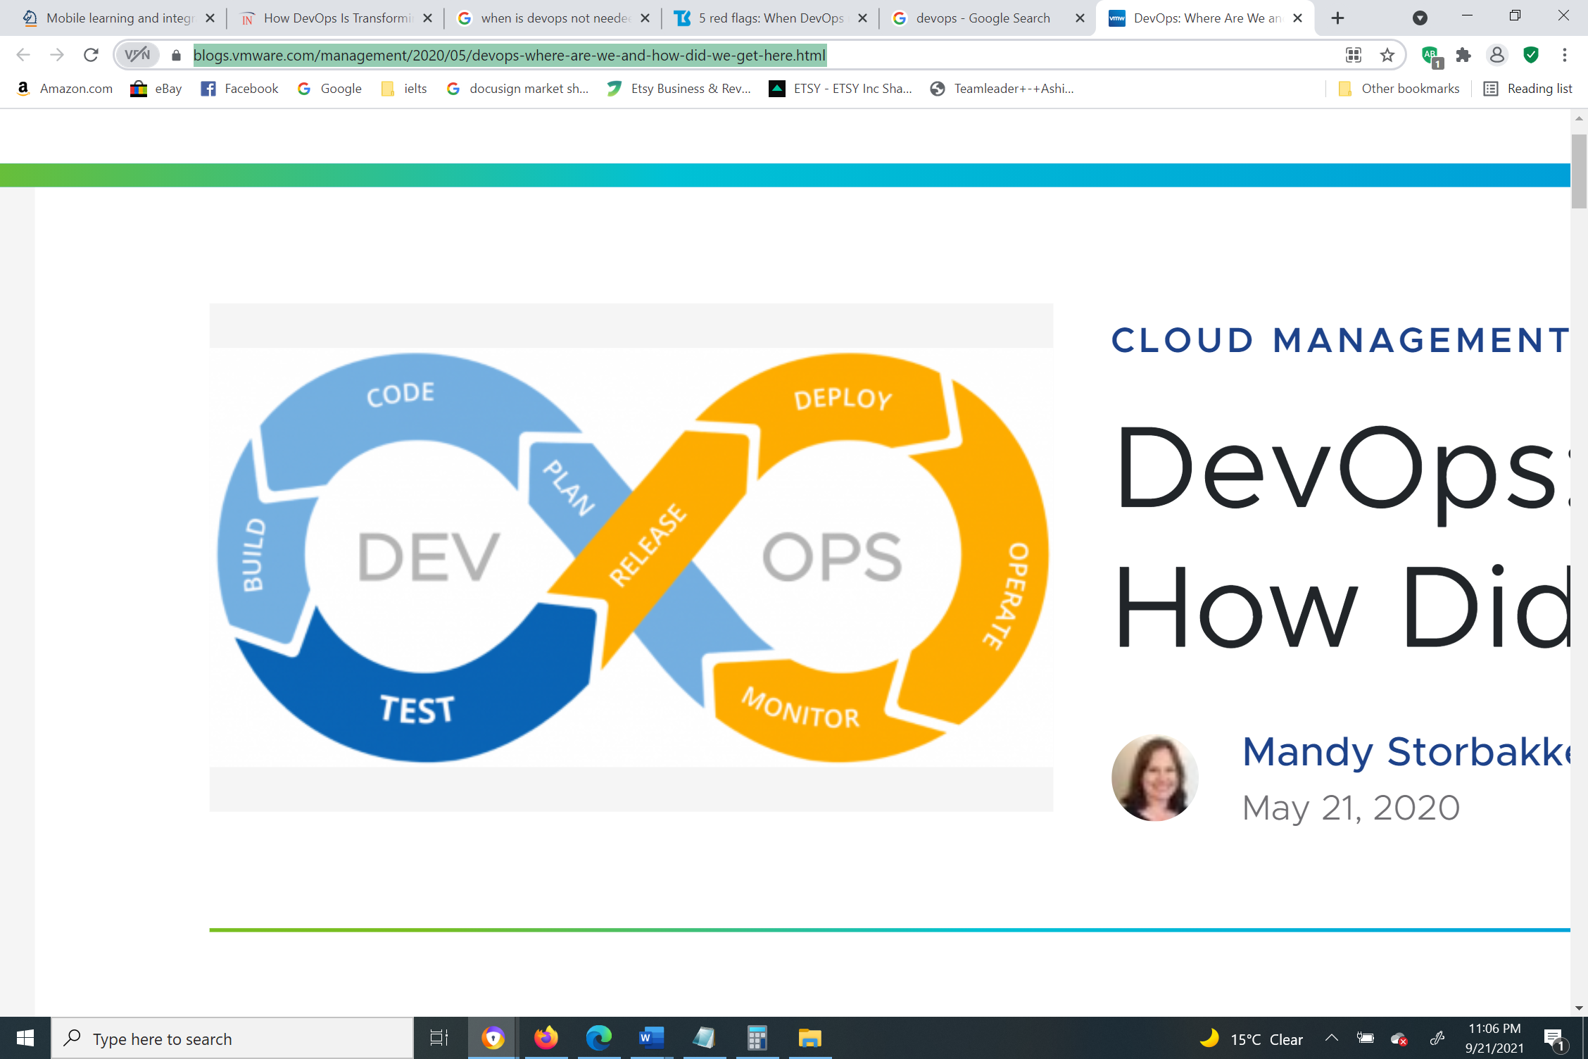

Figure 2 - 12 Development and IT Operations

*Source: https://blogs.vmware.com/management/2020/05/devops-where-are-we-and-how-did-we-get-here.html*

The focus on education is on trade subjects such as plumbing, culinary, auto body, electrician, etc., which are non-technical subjects that do not require intensive IT education. *WeTeachTrades.com*’sbusiness model does not include development and IT operations and there is no demand for numerous frequent releases of products to customers. At this stage, the organization is convinced with the existing state of software and will not dwell on the thought of DevOps benefitting the organization.

* **Microservices**

Microservices architecture is a method in which individual applications are made of numerous smaller services that are loosely coupled and individually deployed. (IBM) The applications at *WeTeachTrade.com* are not large enough to be broken down. The expense of incorporating microservices is high as it requires a minuscule number of resources concerning workforce and computational fees. The organization is currently content with its monolithic architecture in which all services are run at the same time, unlike microservices. The following figure differentiates between monolithic architecture and microservices architecture.

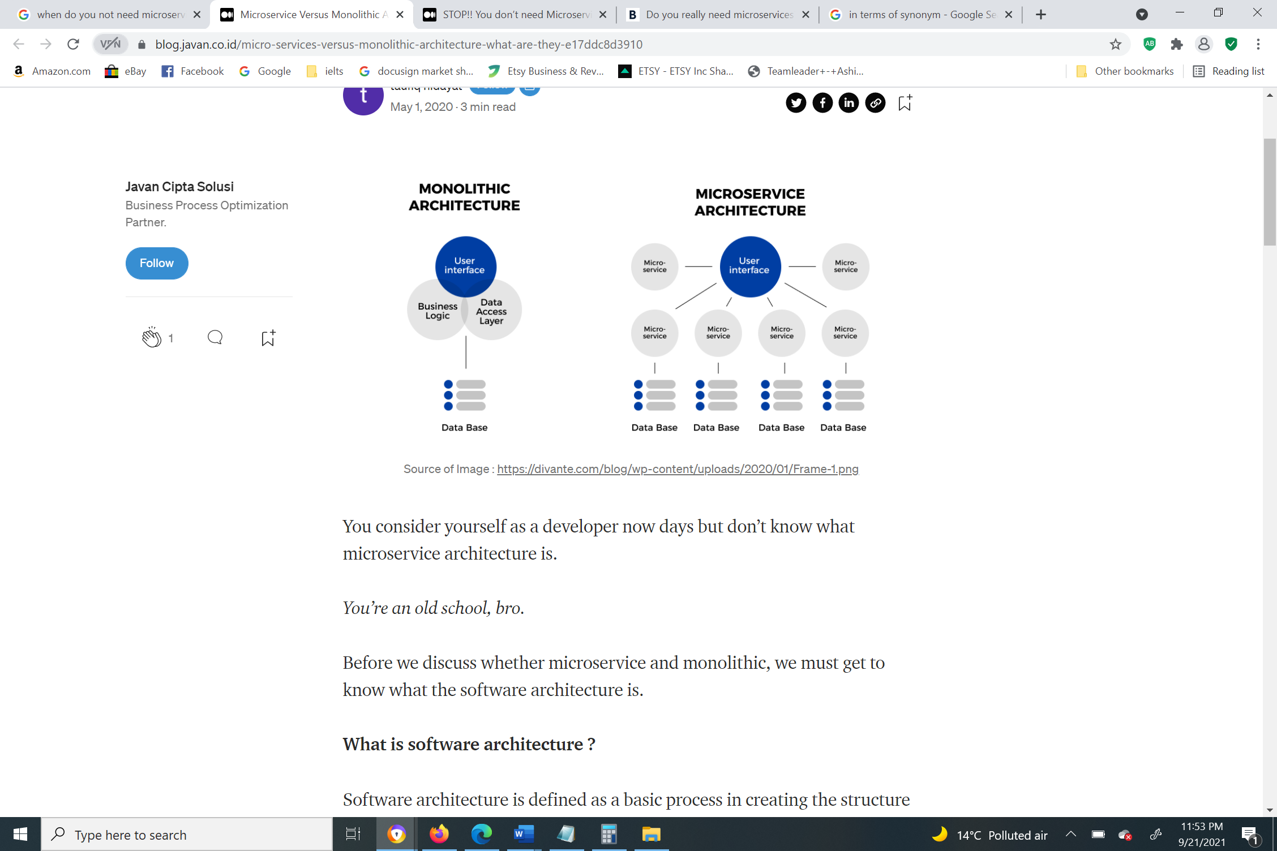

Figure 2 - 13 Monolithic architecture vs. Microservice architecture

Conclusion

*WeTeachTrade.com*  has integrated the best of emerging technologies that are suitable for the business from a strategic and operational perspective. There is no doubt on the selected technologies returning value to the business. In conclusion, this paper discusses why a set of technologies fits the business over the others. However, these are considered keeping the current state of software and the business in mind.

References

1. “What Is Big Data?” *Oracle*, www.oracle.com/big-data/what-is-big-data. Accessed 21 Sept. 2021.
2. “Student Success Programs.” *Georgia State University*, success.gsu.edu/approach. Accessed 21 Sept. 2021.
3. “Among Millennials, Facebook Far Exceeds Any Other Source for Political News | Pew Research Center.” *Pew Research Center’s Journalism Project*, 28 May 2015, www.pewresearch.org/journalism/2015/06/01/millennials-political-news/pj_15-06-01_millennialmedia08.
4. “What Is Software as a Service (SaaS): A Beginner’s Guide.” *Salesforce.Com*, www.salesforce.com/in/saas. Accessed 22 Sept. 2021.
5. “AR Home.” *Google AR & VR*, arvr.google.com/ar. Accessed 22 Sept. 2021.
6. “Microservices.” *IBM*, IBM Cloud Education, 30 Mar. 2021, www.ibm.com/cloud/learn/microservices.